Text Adventure Engine

Pradeepto Pal | Class – XII C | Roll No – 30

CertificatE

This is to certify that Pradeepto Pal of Class XII, DAV Public School, Rajendra Nagar has successfully completed the computer science project during the academic session 2023-2024.

He has prepared the project under my guidance and as per the norms as per the norms by the CBSE boards.

**Subject Teacher**

**_____________________**

Acknowledgements

I would like to express my gratitude toward to my Computer Science teacher Ms. Shipra, her valuable guidance and I am grateful to her for providing me with the opportunity to work on this Project.

I would also like to thank my parents and friends for encouraging me during the course of this project.

Finally, I would like to thank the CBSE board for giving me this great opportunity to do this project.

Index

|  |  |
| --- | --- |
| S. No. | Contents |
| 1. | Introduction |
| 2. | Menu Choices |
| 3. | Data Flow Diagram |
| 4. | Menu Choices |
| 5. | Output Screen |
| 6. | Bibliography |

Introduction

“You learned a lot by playing RPGs, although not all of it was useful, or real for that matter – unless you really believed that wolves normally carry seven gold pieces, a flawed garnet, a scroll of ice storm, and a lock pick somewhere about their person.”  
― **Sorin Suciu**

On October 1958, “Tennis for Two”, the first ever video game was revealed to the world. Created by William Higginbotham, this was the first of its kind and paved the way for the popular game, “Pong”. Little did Higinbotham realize that day that he had started a revolutionarymovement. A movement that would continue to grow for years to come, eventually reshaping the entertainment industry into what it is today.

The history of role-playing games begins with an earlier tradition of role-playing, which combined with the rulesets of fantasy wargames in the 1970s to give rise to the modern role-playing game. A role-playing game (RPG) is a type of game in which the participants assume the roles of characters and collaboratively create stories.

The main objective of this project is to create and implement a code to make an engaging RPG game.

Menu choices

Data Flow Diagram

Code

Output Screen

Beginning

Data Flow Diagram

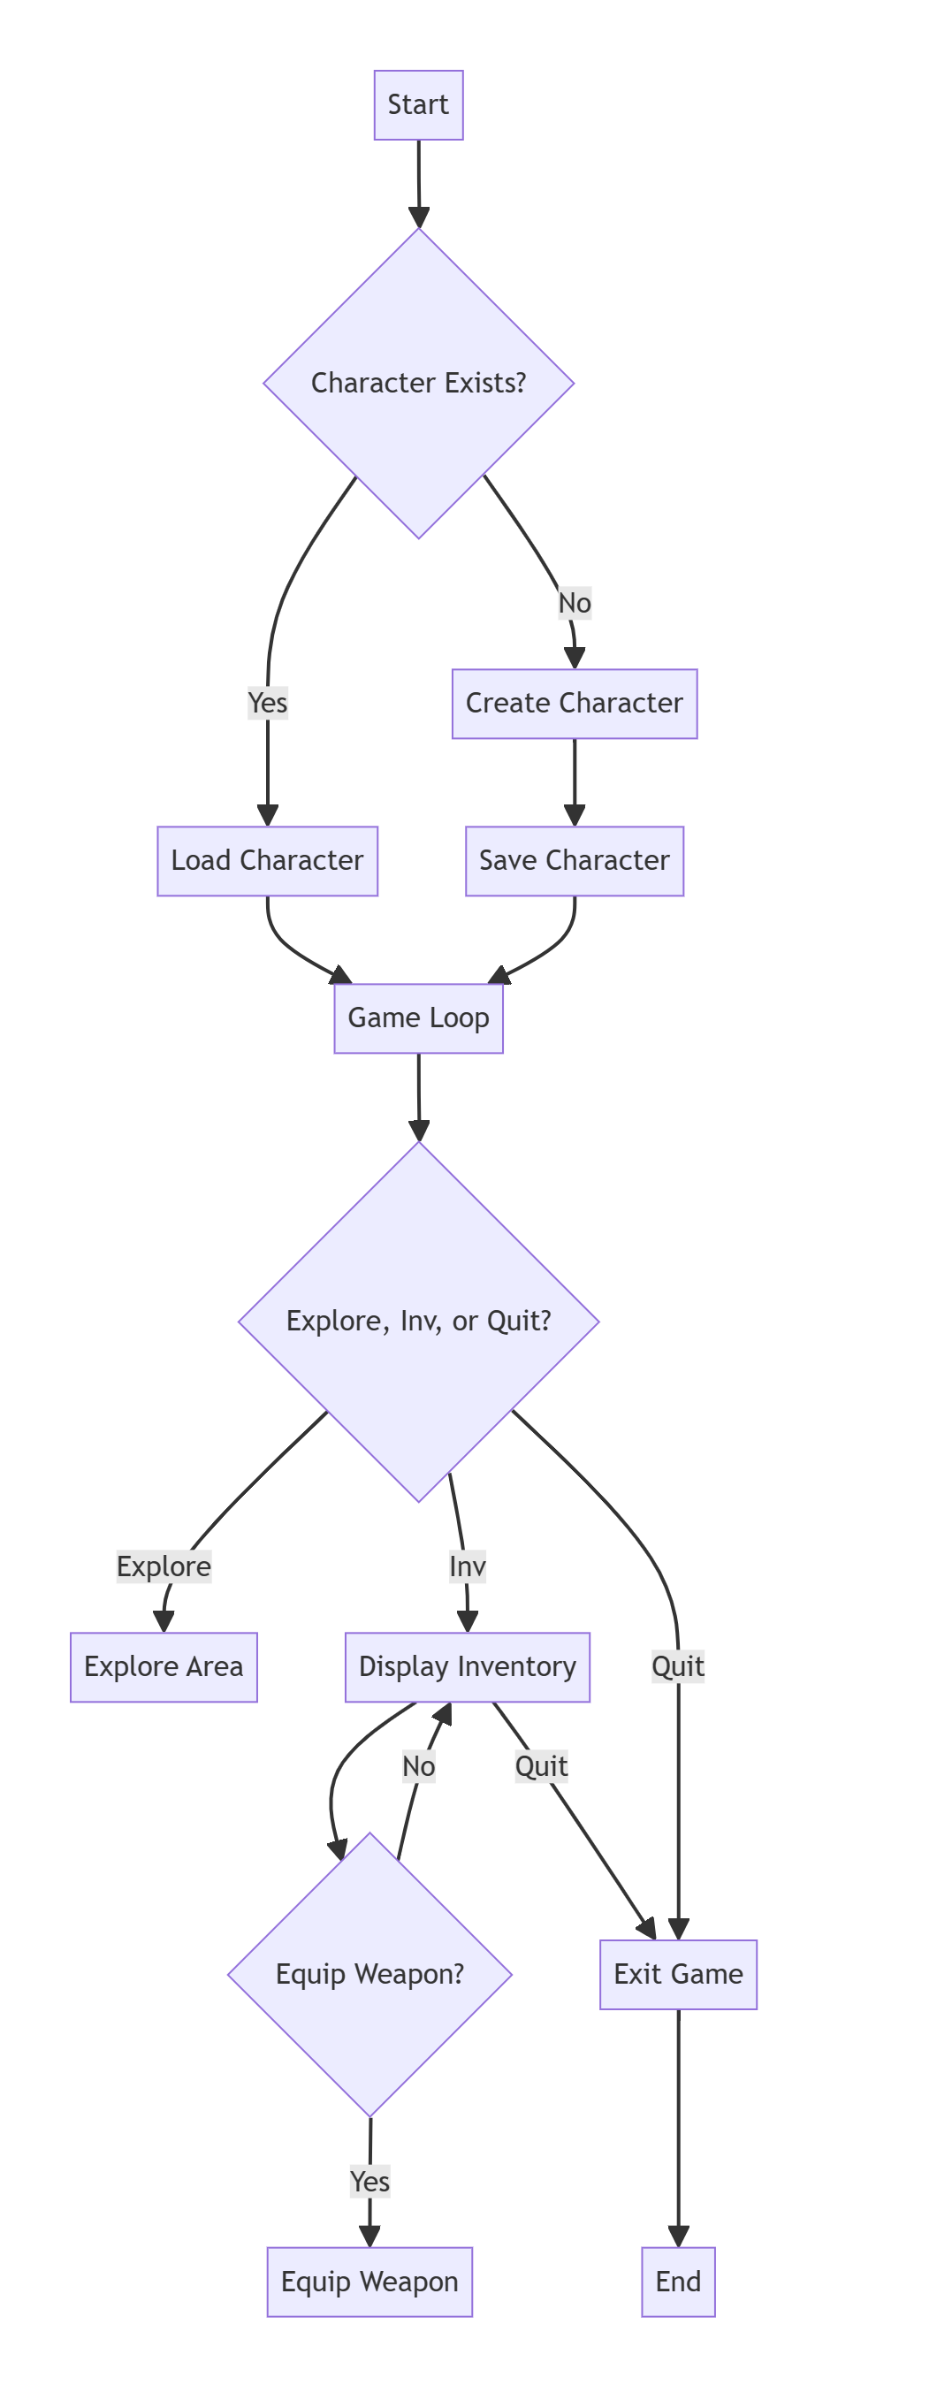

Code

import json

import random

class Weapon:

    def __init__(self, name, damage_range):

        self.name = name

        self.damage_range = damage_range

    def to_json(self):

        return {

            "name": self.name,

            "damage_range": self.damage_range,

        }

class WeaponEncoder(json.JSONEncoder):

    def default(self, obj):

        if isinstance(obj, Weapon):

            return obj.to_json()

        return super().default(obj)

def create_character():

    print("Welcome to the Text-based RPG!")

    name = input("Enter your character's name: ")

    character = {

        "name": name,

        "health": 100,

        "strength": 10,

        "intelligence": 10,

        "dexterity": 10,

        "level": 1,

        "exp": 0,

        "bonus_points": 0,

        "current_weapon": None,

        "inventory": [],

    }

    return character

def save_character(character):

    with open("character_data.txt", "w") as file:

        character_data = json.dumps(character, cls=WeaponEncoder)

        file.write(character_data)

def load_character():

    try:

        with open("character_data.txt", "r") as file:

            character_data = json.load(file)

        character_data.setdefault('current_weapon', None)

        character_data.setdefault('inventory', [])

        character_data['inventory'] = [

            Weapon(item['name'], item['damage_range']) if 'damage_range' in item else item

            for item in character_data['inventory']

        ]

        if 'current_weapon' in character_data and character_data['current_weapon'] is not None:

            character_data['current_weapon'] = Weapon(character_data['current_weapon']['name'],

                                                      character_data['current_weapon']['damage_range'])

        character = character_data

        return character

    except FileNotFoundError:

        return None

    except json.JSONDecodeError as e:

        print(f"Error decoding JSON: {e}")

        return None

    except Exception as e:

        print(f"An unexpected error occurred: {e}")

        return None

def level_up(character):

    print(f"Congratulations, {character['name']}! You leveled up!")

    character['level'] += 1

    character['exp'] = 0

    character['bonus_points'] += 1

    character['health'] += random.randint(5, 10)

    character['strength'] += random.randint(1, 3)

    character['intelligence'] += random.randint(1, 3)

    character['dexterity'] += random.randint(1, 3)

def allocate_bonus_points(character):

    print(f"You have {character['bonus_points']} bonus points to allocate.")

    print("1. Health")

    print("2. Strength")

    print("3. Intelligence")

    print("4. Dexterity")

    choice = input("Choose an attribute to allocate a bonus point (1-4): ")

    if choice.isdigit() and 1 <= int(choice) <= 4:

        attribute = ""

        if choice == "1":

            attribute = "health"

        elif choice == "2":

            attribute = "strength"

        elif choice == "3":

            attribute = "intelligence"

        elif choice == "4":

            attribute = "dexterity"

        character[attribute] += 1

        character['bonus_points'] -= 1

        print(f"You allocated a bonus point to {attribute}.")

    else:

        print("Invalid choice. Bonus point not allocated.")

def print_character_info(character):

    print("\n----- Character Info -----")

    print(f"Name: {character['name']}")

    print(f"Level: {character['level']}")

    print(f"Health: {character['health']}")

    print(f"Strength: {character['strength']}")

    print(f"Intelligence: {character['intelligence']}")

    print(f"Dexterity: {character['dexterity']}")

    print(f"Experience: {character['exp']}")

    print(f"Bonus Points: {character['bonus_points']}")

    print("Current Weapon:", end=" ")

    if character['current_weapon']:

        print(f"{character['current_weapon'].name} ({character['current_weapon'].damage_range[0]} - {character['current_weapon'].damage_range[1]} damage)")

    else:

        print("None")

    print("Inventory:")

    for item in character['inventory']:

        if isinstance(item, Weapon):

            print(f"- {item.name} ({item.damage_range[0]} - {item.damage_range[1]} damage)")

        else:

            print(f"- {item}")

    print("-------------------------")

def run_away(character):

    success_rate = character['dexterity'] * 2

    return random.randint(1, 100) <= success_rate

def encounter_boss(character):

    print("You encounter a fearsome boss!")

    choice = input("Do you want to (F)ight or (R)un? ").lower()

    if choice == 'f':

        boss_strength = 20

        battle(character, boss_strength)

    elif choice == 'r':

        if run_away(character):

            print("You successfully ran away!")

        else:

            print("You couldn't escape! Prepare for battle.")

            boss_strength = 20

            battle(character, boss_strength)

    else:

        print("Invalid choice. The boss eyes you menacingly.")

    print("The evil force's influence intensifies, manifesting into a fearsome creature known as the Shadow Serpent.")

    print("It lurks in the shadows, terrorizing the village. It's up to you to confront this menace and protect your home.")

    enemy_strength = random.randint(15, 25)

    print("\nMiniboss Encounter:")

    print(f"You encounter the Shadow Serpent with strength {enemy_strength}!")

    choice = input("Do you want to (F)ight or (R)un? ").lower()

    if choice == 'f':

        battle(character, enemy_strength)

        # Check if the player won the battle

        if character['exp'] >= 0:

            print("\n----- Conclusion -----")

            print(f"Congratulations, {character['name']}! You have defeated the Shadow Serpent and become the village's new hero.")

            print("The village is saved, and your courage is celebrated by all.")

        else:

            print("\n----- Conclusion -----")

            print(f"Despite the challenges, {character['name']} couldn't defeat the Shadow Serpent.")

            print("The village struggles under the influence of the evil force.")

        print("\nThank you for playing the Text-based RPG. Goodbye!")

    elif choice == 'r':

        if run_away(character):

            print("You successfully retreat, but the Shadow Serpent's presence lingers over the village.")

        else:

            print("You couldn't escape! Prepare for battle.")

            battle(character, enemy_strength)

    else:

        print("Invalid choice. The Shadow Serpent hisses in anticipation.")

def explore_area(character):

    if random.choice([True, False]):

        enemy_strength = random.randint(5, 15)

        print(f"\nYou encounter an enemy with strength {enemy_strength}!")

        choice = input("Do you want to (F)ight or (R)un? ").lower()

        if choice == 'f':

            battle(character, enemy_strength)

        elif choice == 'r':

            if run_away(character):

                print("You successfully ran away!")

            else:

                print("You couldn't escape! Prepare for battle.")

                battle(character, enemy_strength)

    else:

        encounter_boss(character)

def generate_loot():

    loot_types = ["Gold", "Health Potion", "Sword", "Axe", "Bow"]

    return random.choice(loot_types)

def add_to_inventory(character, loot):

    if loot == "Gold":

        character['inventory'].append(loot)

        print(f"You found {loot}!")

    elif loot == "Health Potion":

        character['inventory'].append({"name": loot})

        print(f"You found a {loot}! It has been added to your inventory.")

    elif loot in ["Sword", "Axe", "Bow"]:

        weapon = {"name": loot, "damage_range": [5, 15]}

        character['inventory'].append(weapon)

        print(f"You found a {loot}! It has been added to your inventory.")

    else:

        print("Unknown item.")

def battle(character, enemy_strength):

    # Simulate a battle

    if character['strength'] >= enemy_strength:

        print("You defeated the enemy!")

        character['exp'] += random.randint(10, 20)

        # Check if the player leveled up

        if character['exp'] >= 50:

            level_up(character)

            allocate_bonus_points(character)

        # Generate loot after defeating an enemy

        loot = generate_loot()

        add_to_inventory(character, loot)

    else:

        print("You were defeated. Game Over.")

def main():

       character = load_character()

    if character is None:

        print("No character found. Let's create a new one.")

        character = create_character()

        save_character(character)

    else:

        print(f"Welcome back, {character['name']}!")

    # Game loop

    while character['level'] <= 5:          print_character_info(character)

        # Explore or Exit

        choice = input("Do you want to (E)xplore, (I)nv, or (Q)uit? ").lower()

        if choice == 'e':

            explore_area(character)

        elif choice == 'i':

            # Display inventory

            print("Inventory:")

            for item in character['inventory']:

                if isinstance(item, Weapon):

                    print(f"- {item.name} ({item.damage_range[0]} - {item.damage_range[1]} damage)")

                else:

                    print(f"- {item}")

            equip_choice = input("Type the name of the weapon you want to equip (or type 'Q' to go back): ").capitalize()

            if equip_choice == 'Q':

                continue

            found_weapon = None

            for item in character['inventory']:

                if isinstance(item, Weapon) and item.name.lower() == equip_choice.lower():

                    found_weapon = item

                    break

                elif isinstance(item, dict) and 'name' in item and item['name'].lower() == equip_choice.lower():

                    found_weapon = Weapon(item['name'], item['damage_range'])

                    break

            if found_weapon:

                character['current_weapon'] = found_weapon

                print(f"You have equipped {found_weapon.name}.")

            else:

                print("Invalid choice. No such weapon in your inventory.")

        elif choice == 'q':

            print("Exiting the game. Goodbye!")

            break

        # Save character data

        save_character(character)

if __name__ == "__main__":

    main()

Output Screen

**Files:**

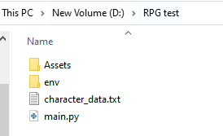

**Start:**

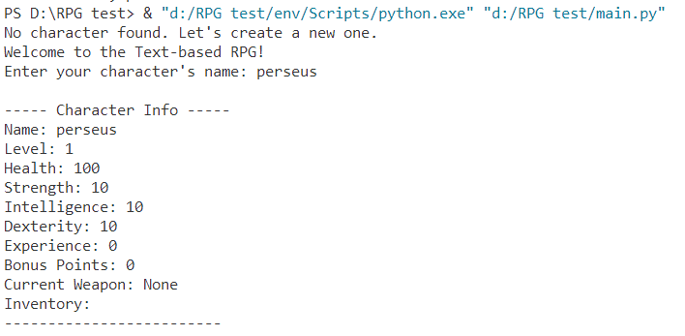

**Level Up:**

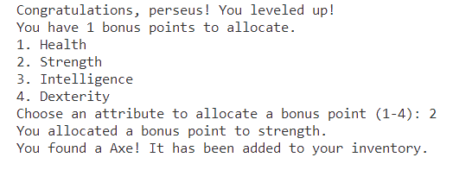

**Re-logging:**

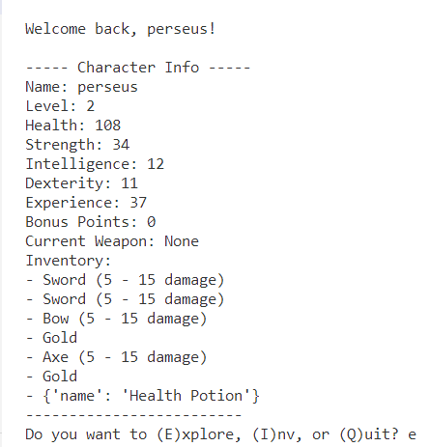

**Enemies:**

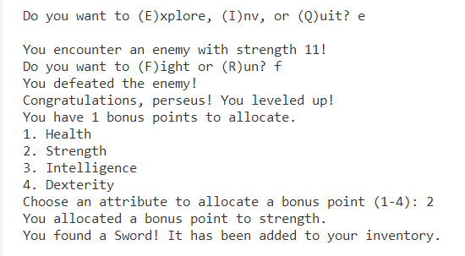

**Boss:**

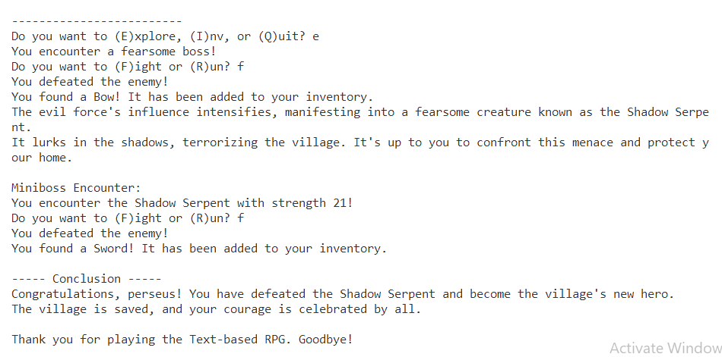

Bibliography

* CodeToFlow :- Helping with the Flow chart of the code.

<https://codetoflow.com>

* Wikipedia :- History of Games and RPG

<https://www.wikipedia.org>